Question 1
A gentleman fell from stairs and sustained left shoulder injury.
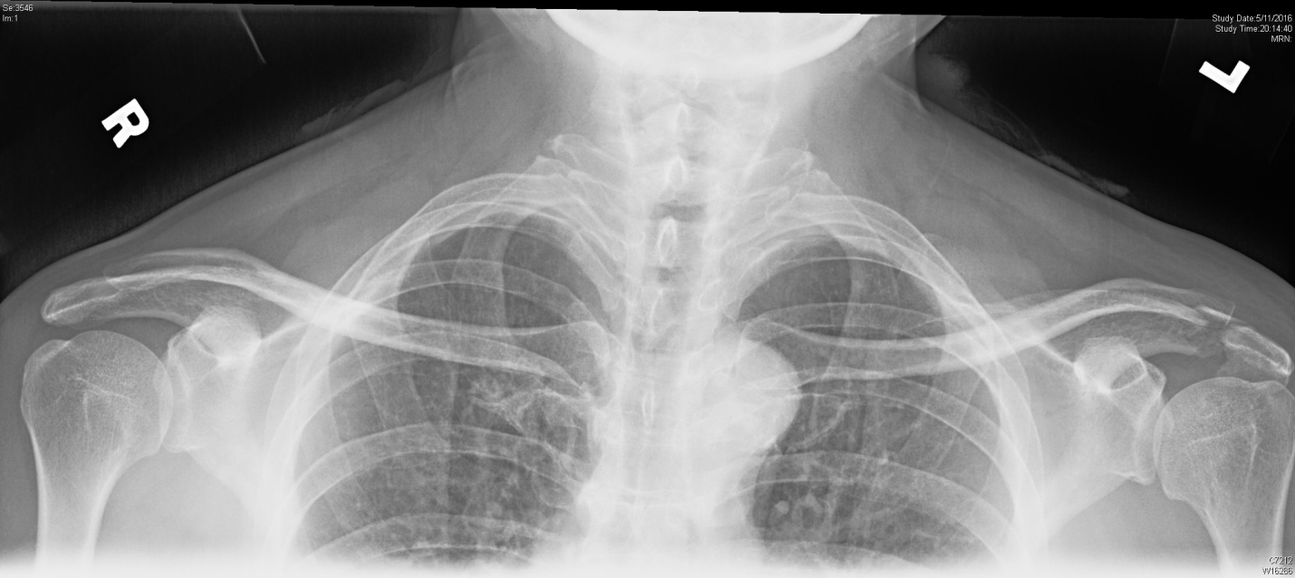

- Name the pathology from the X ray? 1 point
- If you are not certain about the diagnosis, what supplemental views would be helpful? 3 points
- What is the potential soft tissue complication of this injury? 1 point
- How do you look for this complication on physical examination? (Briefly describe 2 methods. What tests are they named? ) 4 points
- What are the treatment options of this injury? 2 points

Question 2
A 42 years old man presented with shortness of breath, sore throat and neck swelling. He had a medical history of diabetes and obesity. The oxygen saturation could be maintained at 93% on high flow oxygen.

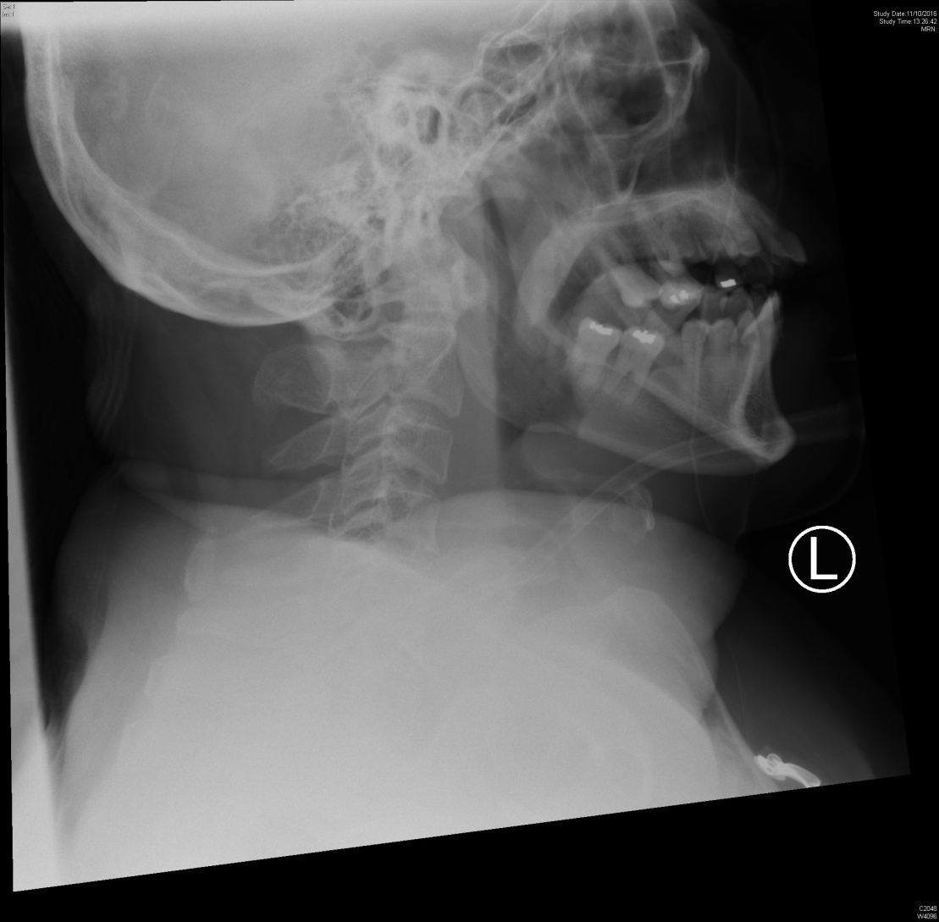

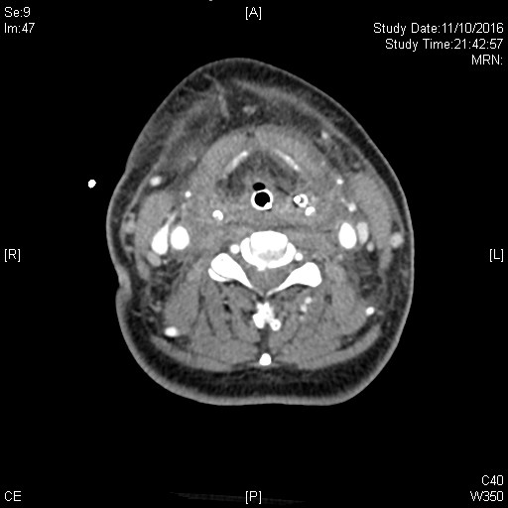

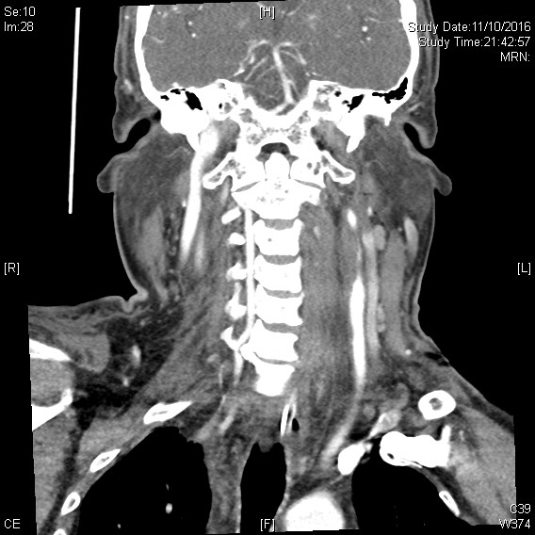

- Describe two important findings on the X-ray 2 points
- How would you confirm your suspicion without an imaging technique? 1 point
- CT scan with contrast was performed. A complication of this condition was found.
Name one important CT finding. 1 point
- What is the name of this complication? 1 point
- What are the two treatment options for this complication? 2 points
- If patient needed to transfer out for treatment, what should be done first? 1point
- Describe how you can perform the above management decision?
2 points

Question 3a
- A 72 years old male presented with a few days history of malaise and dizziness. He denied any chest pain. Vital signs were stable except the slow heart rate. I-stat showed no significant electrolyte disturbance. ECG was performed.

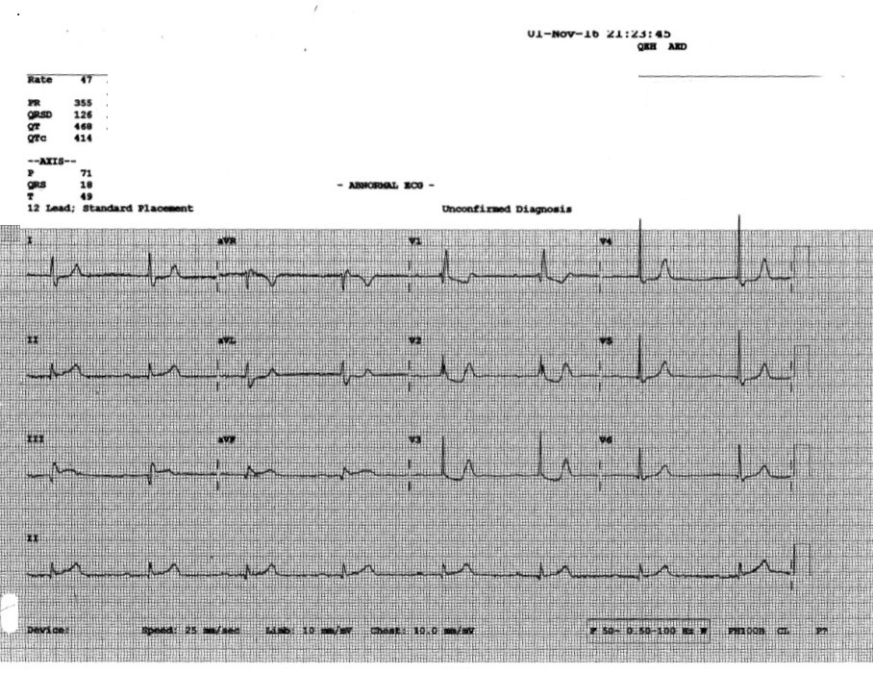
- Describe the ECG finding? 4 points
- What is the diagnosis? 1 points
- Was thrombolytic therapy indicated for this patient? 1 point

Question 3b
A 45 years old man presented with chest pain. Acute coronary syndrome was suspected clinically. ECG was performed.
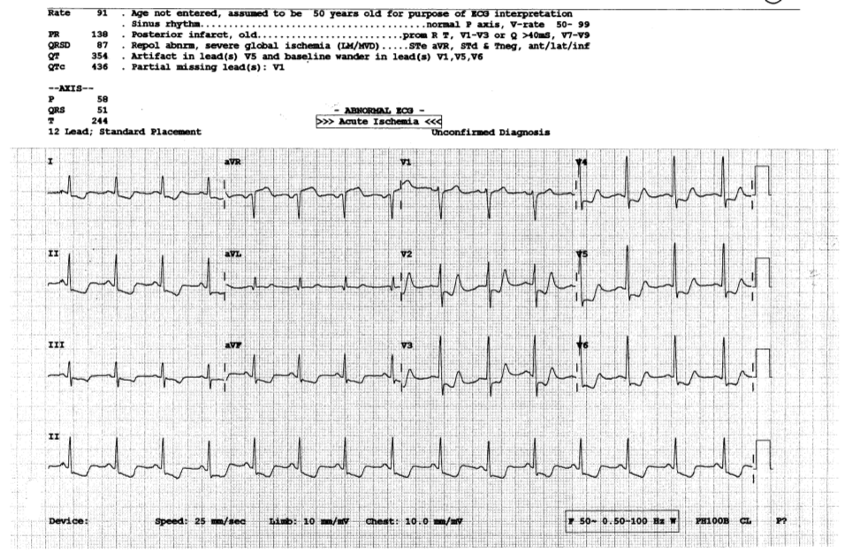

- What are the ECG findings? 2 points
- What are the implications of this ECG on location of the culprit artery and prognosis? 2 points
- What ECG finding will prompt you to look for RV or posterior wall infarct? 2 points

Question 4
- This question is concerning about fracture hip. Four patients presented with hip contusion. Their x rays were shown.
Patient A
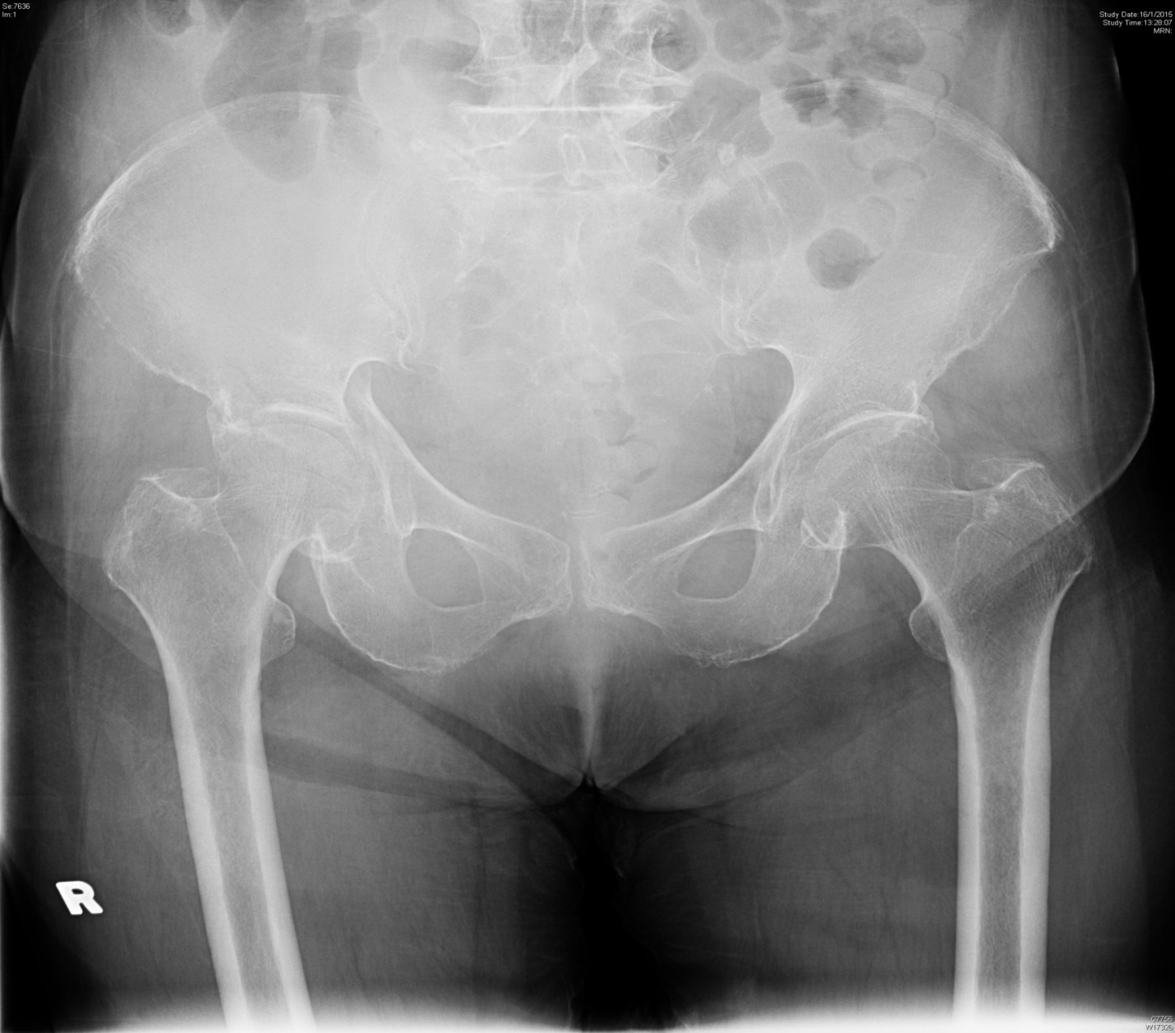

Patient B
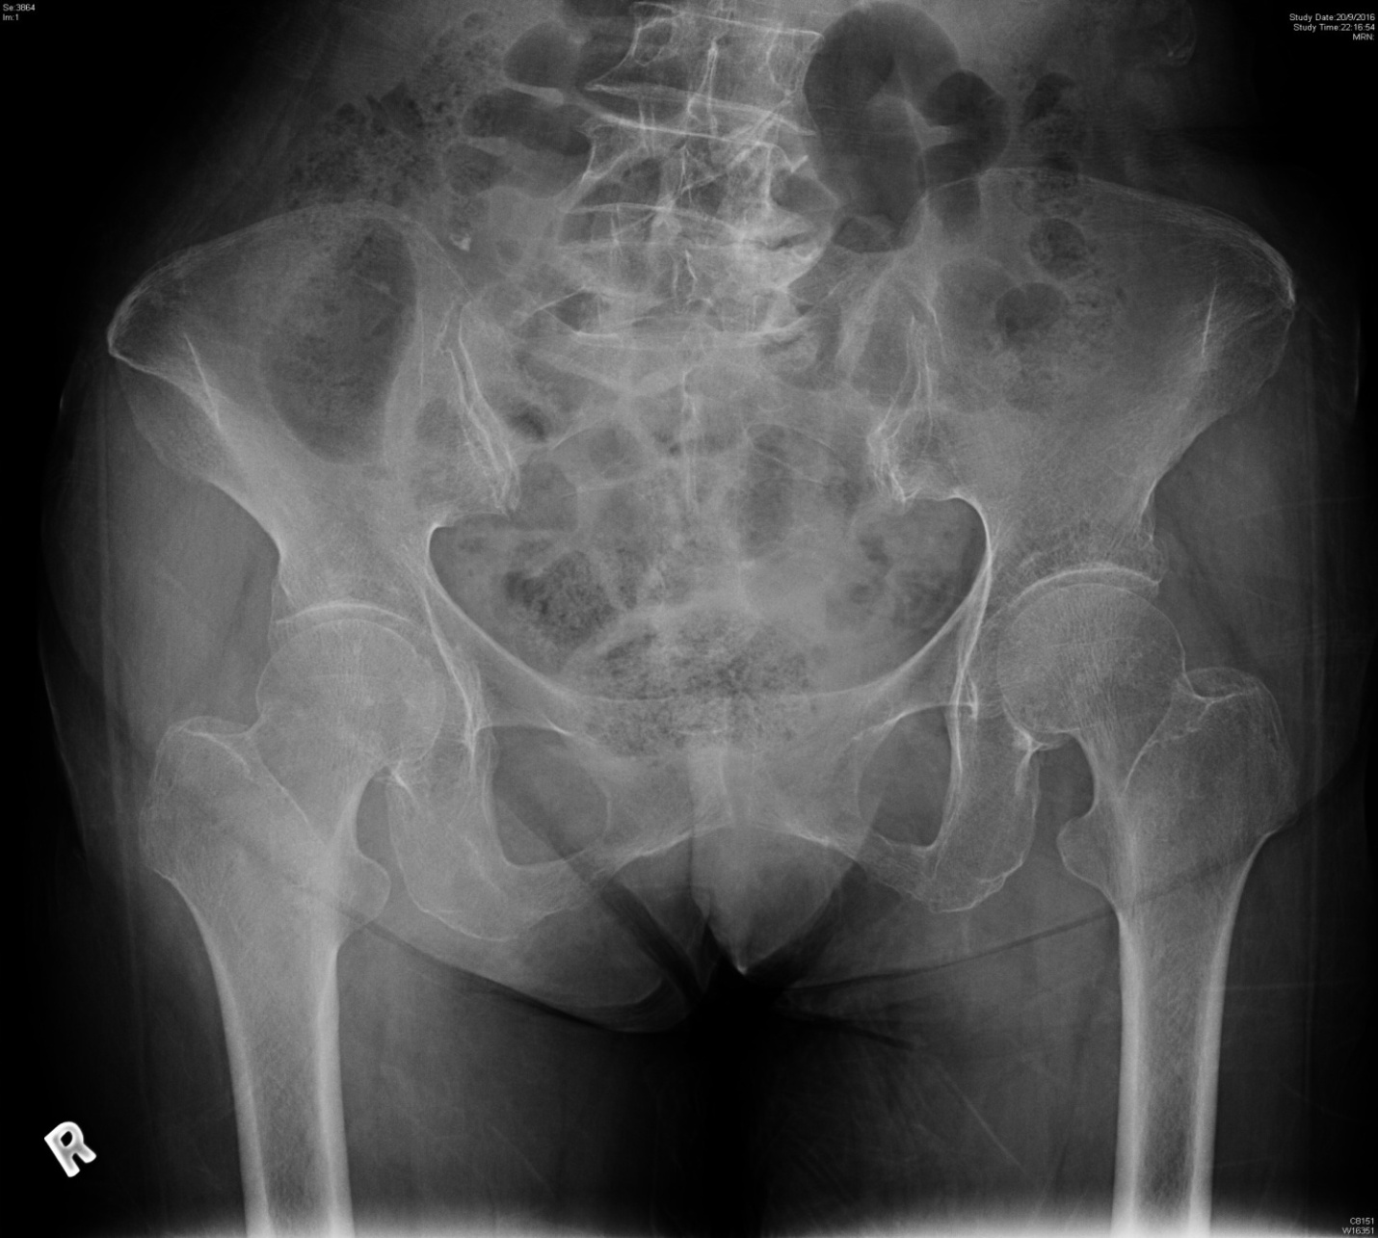

Patient C
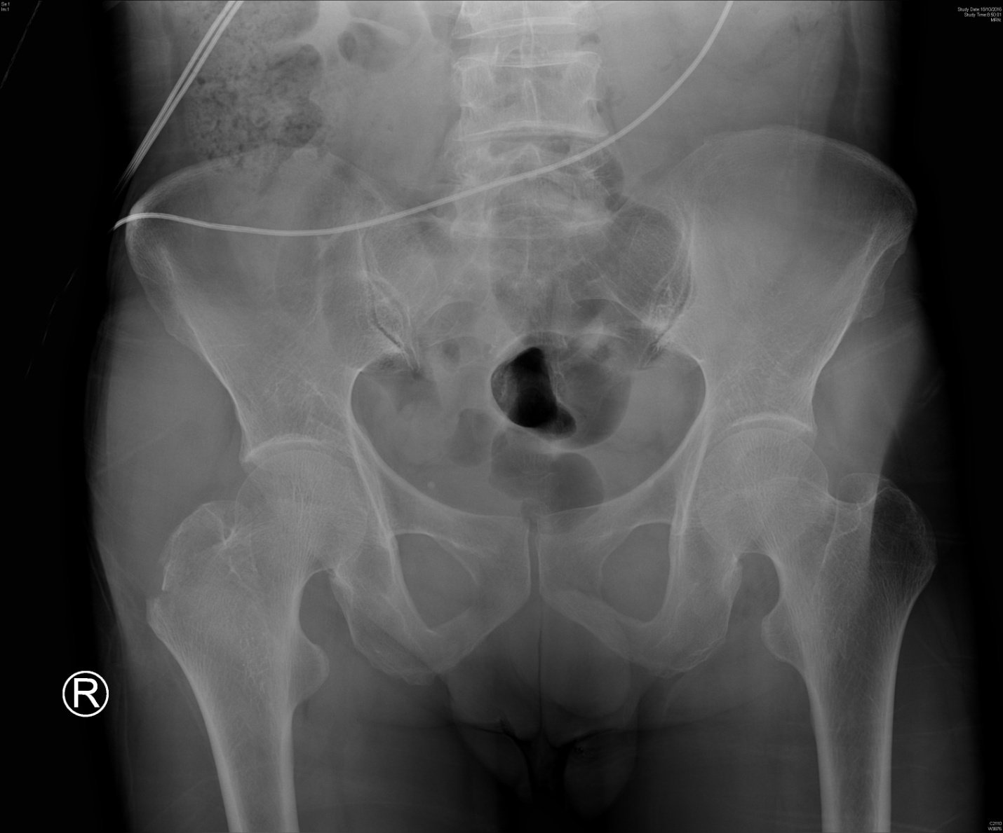

Patient D
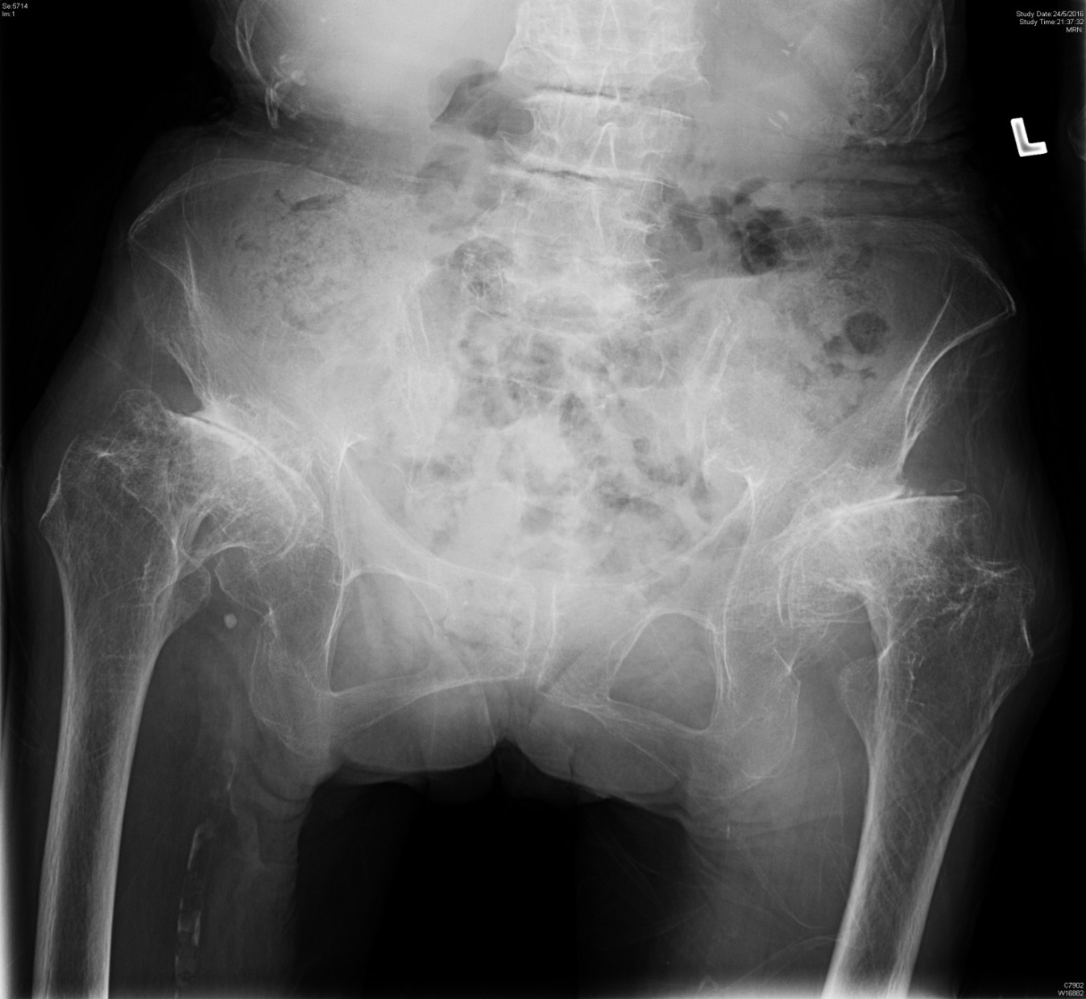

- Please point out the fracture site on each X ray. 4 points
- What is the alternative method of pain relief apart from systemic analgesic?
1 point
- For fracture neck of femur, what is the most worried (orthopedic) complication? 1 point
- What are the operative treatment options for displaced fracture femoral neck in young patients and geriatric patients respectively? 2points

Question 5
A 20-year-old lady traveled to Kenya for 10 days, returned since one week ago, presented to A&E with fever and headache for 3 days. There was also vomiting and diarrhea. GCS 15, BP 130/80mmHg, pulse 115bpm. Temp 41.3C.
- Name four differential diagnoses in relation to the travel history? 5 points

Screen for malaria was performed.

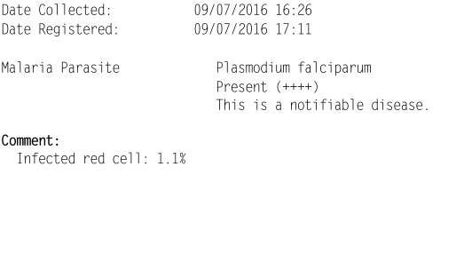

- How do you interpret the parasite count? It is low or high parasite densities? 1 point
- What are the principles of management of malaria in ED? 4 points
- What are the effect of malaria on mother and fetus? 2 points
- What are the drugs of choice for malaria (mainly P. falciparum) in pregnancy? 2 points

